20/11/25
Dear Families,
Our lovely children and teachers have started work on their Winter Performances. Re base children will be singing festive songs at 2pm and Yellow, Green and Blue base children will do their performance of ‘The Grinch’ at 2.30pm. All parents/carers are welcome to watch both performances if they wish.
Tickets for the performances will be £3 per adult attending and are limited to 2 per child due to limited space. If finances are stretched at this time of year and you can’t pay then you are still very welcome to attend, we don’t want anybody to miss out on this special event.
This will be followed by the Fayre which will start at 3pm and will include stalls for the classes to sell things they have made in school, hot drinks, a bake sale and our famous raffle! It promises to be a magical occasion!
All money raised will be split between the school (they will use it to optimise access to amazing enrichment opportunities for all children through the school year) two charities that have been carefully chosen by the school council – the RSPCA and Homewards Homeless Project;
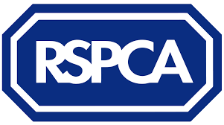

***How can you help and be more involved?...***
- Volunteer on the day, set up will start from 1pm and then everyone will watch the performance, helpers will be required again afterwards to help man the stalls and then help clear away (contact esmeohobley@gmail.com or inform Mrs Barnes or your class teacher if you are able to help with this)
- Bake something delicious for us to sell at the Fayre – please inform esmeohobley@gmail.com or your class teacher if you plan to do this and bring things on the day ideally by 1330. Include a list of all of the ingredients please so we can be safe about allergens and MAKE IT NUT FREE
- Bring contributions for the class raffle hampers (Red for red base, Yellow (or gold) for yellow etc...) – Anything tasty to eat or drink or nice toiletries would be fab, please bring by the 9th Dec at the latest and give to the office or class teachers.
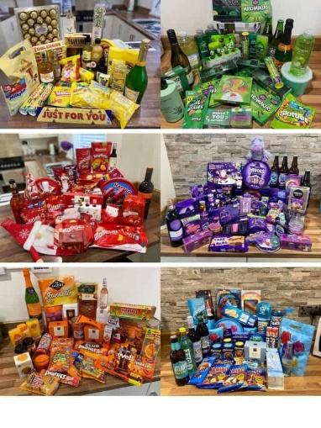
Ideas for Raffle contributions...

We can’t wait for the celebrations to begin!
Thank you very much and wishing you all the best for the festive season,
The FOBs team

