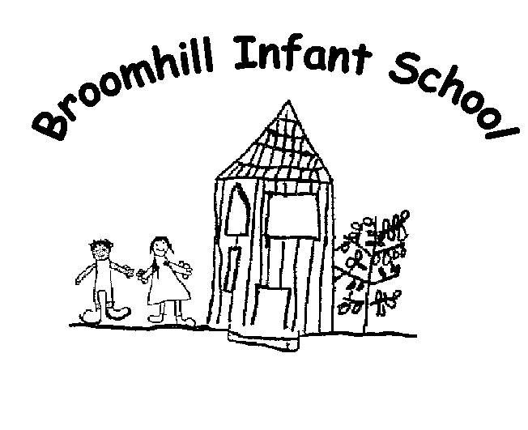
History

Written. November 2007
Revised: November 2023
By Susan Jones
Next review: November 2025
Broomhill Infant School

Policy on History

1 Aims and objectives
1.1 The aim of history teaching at Broomhill Infant School is to stimulate the children's interest and understanding about the life of people who lived in the past. We teach children a sense of chronology, and, through this, they develop a sense of identity, and a cultural understanding based on their historical heritage. Thus, they learn to value their own and other people's cultures in modern multi-cultural Britain and, by considering how people lived in the past, they are better able to make their own life choices today. We teach children to understand how events in the past have influenced our lives today; we also teach them to investigate these past events and, by so doing, to develop the skills of enquiry, analysis, interpretation and problem-solving.
1.2 We aim to develop the children’s substantive and disciplinary knowledge:
- to foster in children an interest in the past, and to develop an understanding that enables them to enjoy all that history has to offer;
- to enable children to know about significant events in history, and to appreciate how things have changed over time;
- to develop a sense of chronology;
- to have some knowledge and understanding of historical development in the wider world;
- to help children understand society and their place within it, so that they develop a sense of their cultural heritage;
- to develop in children the skills of enquiry, investigation, analysis, evaluation and presentation.

2 Teaching and learning style
2.1 History teaching focuses on enabling children to think as historians. We place an emphasis on examining historical artefacts and primary sources. We give children the opportunity to visit sites of historical significance. We encourage visitors to come into the school and talk about their experiences of events in the past. We recognise and value the importance of stories in history teaching, and we regard this as an important way of stimulating interest in the past. We focus on helping children to understand that historical events can be interpreted in different ways, and that they should always ask searching questions, such as 'how do we know?” about information they are given.
2.2 We recognise that in all classes, children have a wide range of ability in history, and we seek to provide suitable learning opportunities so that all children know more and can do more. We achieve this by:
- Use of class timelines to embed the language of chronology and the children’s substantive knowledge. .
- Use of knowledge organisers to share key learning.
- Learning journey wall to map the development of knowledge and skills through a topic.
- Retention and recall activities.
- Use the use of artefacts, visits and visitors to develop the children’s disciplinary skills (being a historian).

3 History curriculum planning
3.1 History is a foundation subject in the National Curriculum. We use the Progression in the national Curriculum document as the basis for our curriculum planning in history, but we have adapted this to our local context, building on the successful units of work already in place. We ensure that there are opportunities for children of all abilities to develop their substantive knowledge and disciplinary skills in each unit. We have carefully mapped out the curriculum over a two-year cycle, ensuring coverage and rigour.
3.2 The long-term plan maps the knowledge and skills covered, including linking to year 3 curriculum content. The subject leader ensures that the Programmes of Study are included in the long-term plan.
3.3 The key stage 1 lead uses the long-term plan to map out a two-year teaching cycle. The KS1 lead ensures coverage and breadth, as well as allowing for revisiting key learning content to make it ‘sticky’.
3.4 The teaching cycle is detailed into a medium-term plan for each learning challenge question. The includes carefully mapping learning objectives that are enriched by Forest School and those that would be more suited to classroom teaching. We use knowledge organisers to regularly recall and retrieve key learning.

5 The contribution of history to teaching in other curriculum areas
5.1 English
History contributes significantly to the teaching of English in our school by actively promoting the skills of reading, writing, speaking and listening. Some of the texts that we use in literacy are historical in nature. Children develop oracy through discussing historical questions, or presenting their findings to the rest of the class. They develop their writing ability by composing recounts, reports and letters.
5.2 Mathematics
The teaching of history contributes to children's mathematical understanding in a variety of ways. Children learn to use numbers when developing a sense of chronology through activities such as creating time lines and through sequencing events in their own lives. Children also learn to interpret information presented in graphical or diagrammatic form.
5.3 Personal, social and health education (PSHE) and British Values
History contributes significantly to the teaching of personal, social and health education and British Values. They discover how to be active citizens in a democratic society by learning how laws are made and changed, and they learn how to recognise and challenge stereotypes, and to appreciate that racism is a harmful aspect of society. They learn how society is made up of people from different cultures, and they start to develop tolerance and respect for others.

5.4 Spiritual, moral, social and cultural development
In our teaching of history, we contribute, where possible, to the children's spiritual development through commemorative dates such as Armistice Day. We also provide children with the opportunity to discuss moral questions, or what is right and wrong and they find out how British society has changed over time. The history programme of study enables children to understand that Britain's rich cultural heritage can be further enriched by the multi-cultural British society of today.

6 History and Computing
6.1 Information and communication technology enhances our teaching of history, wherever appropriate. The children use ICT in a variety of ways, such as word-processing, finding information on the Internet and sometimes presenting information through PowerPoint. They can also use interactive timeline software, and they can make creative use of the ipads to record photographic images and to make short films.

7 History and inclusion
7.1 At our school, we teach history to all children, whatever their ability and individual needs. This accords with the school's curriculum policy of providing a broad and balanced education to all children. Through our history teaching, we provide learning opportunities that enable all pupils to make good progress. We strive hard to meet the needs of those pupils with special educational needs, those with disabilities, those with special gifts and talents, and those learning English as an additional language, and we take all reasonable steps to achieve this. For further details, see separate policies: Special Educational Needs; Disability Discrimination; Gifted and Talented Children; English as an Additional Language (EAL).
7.2 When progress falls significantly outside the expected range, the child may have special educational needs. Our assessment process looks at a range of factors – classroom organisation, teaching materials, teaching style, differentiation – so that we can take some additional or different action to enable the child to learn more effectively. Assessments made by teachers against the National Curriculum's end of key stage expectations allow us to consider each child's attainment and progress in relation to the levels expected. This helps to ensure that our teaching is matched to the child's needs.
7.3 Intervention through Monitoring and SEND Support will lead to the creation of a Support Plan for children with special educational needs. The Support Plan may include, as appropriate, specific targets relating to history.
7.4 We enable all pupils to have access to the full range of activities involved in learning history. Where children are to participate in activities outside the classroom, e.g. a visit to the local museum, the Heritage Centre or the local war memorial, we carry out a risk assessment prior to the activity, to ensure that the activity is safe and appropriate for all pupils.

8 Assessment for learning
8.1 The teacher uses a range of formative assessment tools to ensure children’s retention and recall of key learning. This includes quizzes, exit passes, discussion questions and the learning journey wall.
8.2 At the end of each unit of work the teacher will assess retention and recall by revisiting the knowledge organiser, with key learning missing. The children are expected to complete the missing pieces.
8.3 Teachers use floor books and class timelines to revisit prior learning and build on the children’s fluency of knowledge.

9 Resources
9.1 There are sufficient resources for all history teaching units in the school. We keep these resources in a central store. The library contains a good supply of topic books and we have software to support children's individual research.

10 Monitoring and review
10.1 The history subject leader carries out a termly impact review to triangulate intent, implementation and impact. Any action points are fed into the history action plan, as well as being fed back to the teachers.
10.2 This policy will be reviewed at least every two years.

