Broomhill Infant School

Beech Hill Road
Sheffield S10 2SA
Tel/Fax: 0114 2660936
E-mail: enquiries@broomhill.sheffield.sch.uk

Website: http://broomhill.sheffield.sch.uk

Head teacher: Jane Barnes
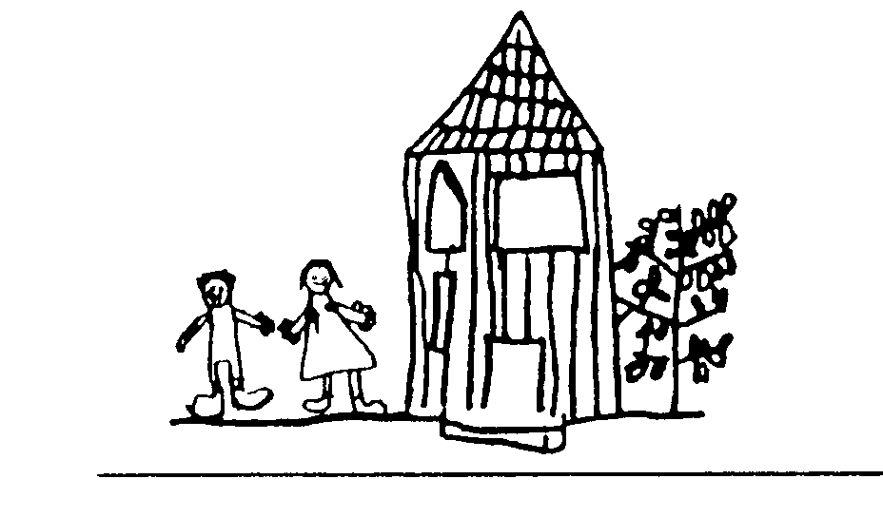

.

Dear Y1 Parents,

For your information:

During the next few weeks, we will be visiting our local church to look at artefacts and the architecture of the building.

No worship is involved. We will be sketching and drawing in order to inform follow up work in school.

Many thanks

Gail Hutt
PE co-ordinator

