Broomhill Infant EYFS Long Term Plan 2023-2024
Overarching Principles | Unique Child: Every child is unique, is constantly learning and can be resilient, capable, confident and self-assured.  Positive Relationships: Children flourish with warm, strong & positive partnerships between all staff and parents/carers. This promotes independence across the EYFS curriculum. Children and practitioners are NOT alone – we embrace each community. Enabling Environments: Children learn and develop well in enabling environments that are safe and secure with teaching and support from adults. Routines are established and adults respond to individual needs and passions and help children to build upon their learning over time.  Learning and Development: Children develop and learn at different rates. We must be aware of children who need greater support than others.
Characteristics of Effective Learning | Playing and Exploring  Children investigate and experience things and have a go. |  | Active Learning  Children concentrate and keep on trying if they encounter difficulties. They enjoy achievements. |  | Creating and Thinking Critically  Children have and develop their own ideas, make links between ideas, and develop strategies for doing things.
Themes to drive the curriculum alongside children’s passions and interests. | Autumn 1  Where do you belong? | Autumn 2  How do you celebrate? | Spring 1  Who is your superhero? | Spring 2  Have you got green green fingers? | Summer 1  Who laid this egg? | Summer 2  Where would you like to go?
Key Texts | 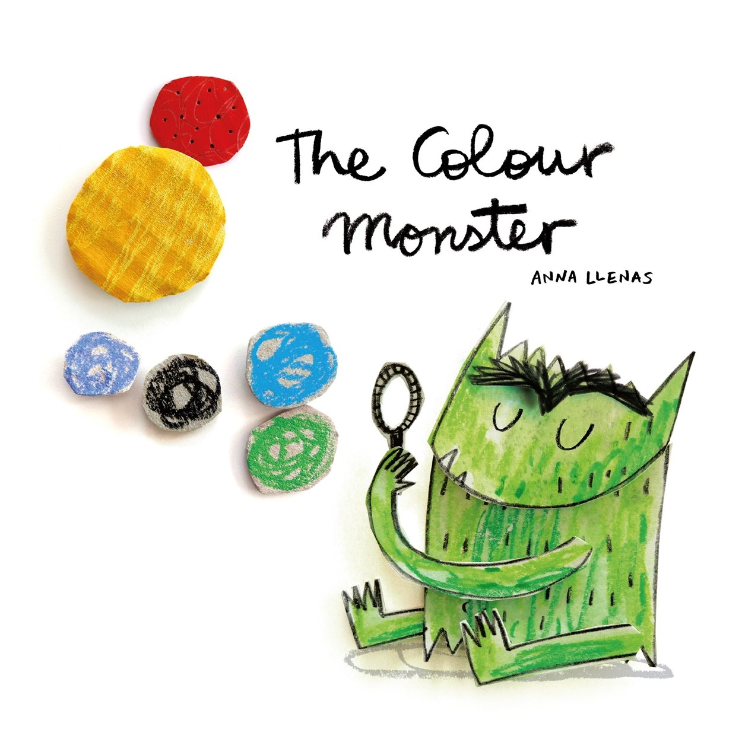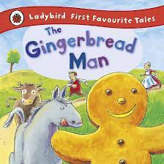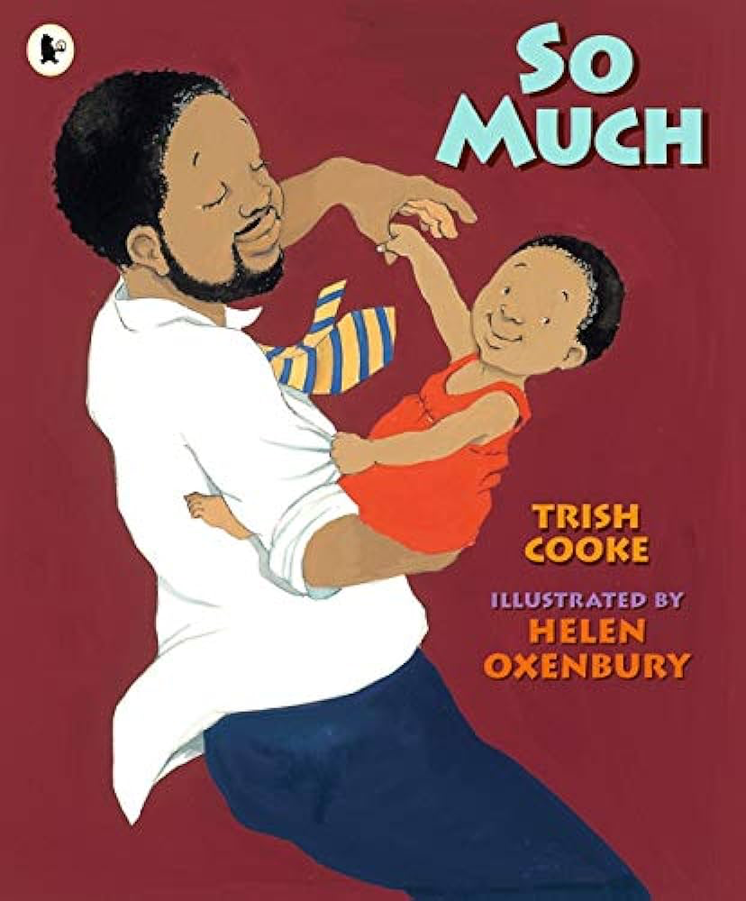  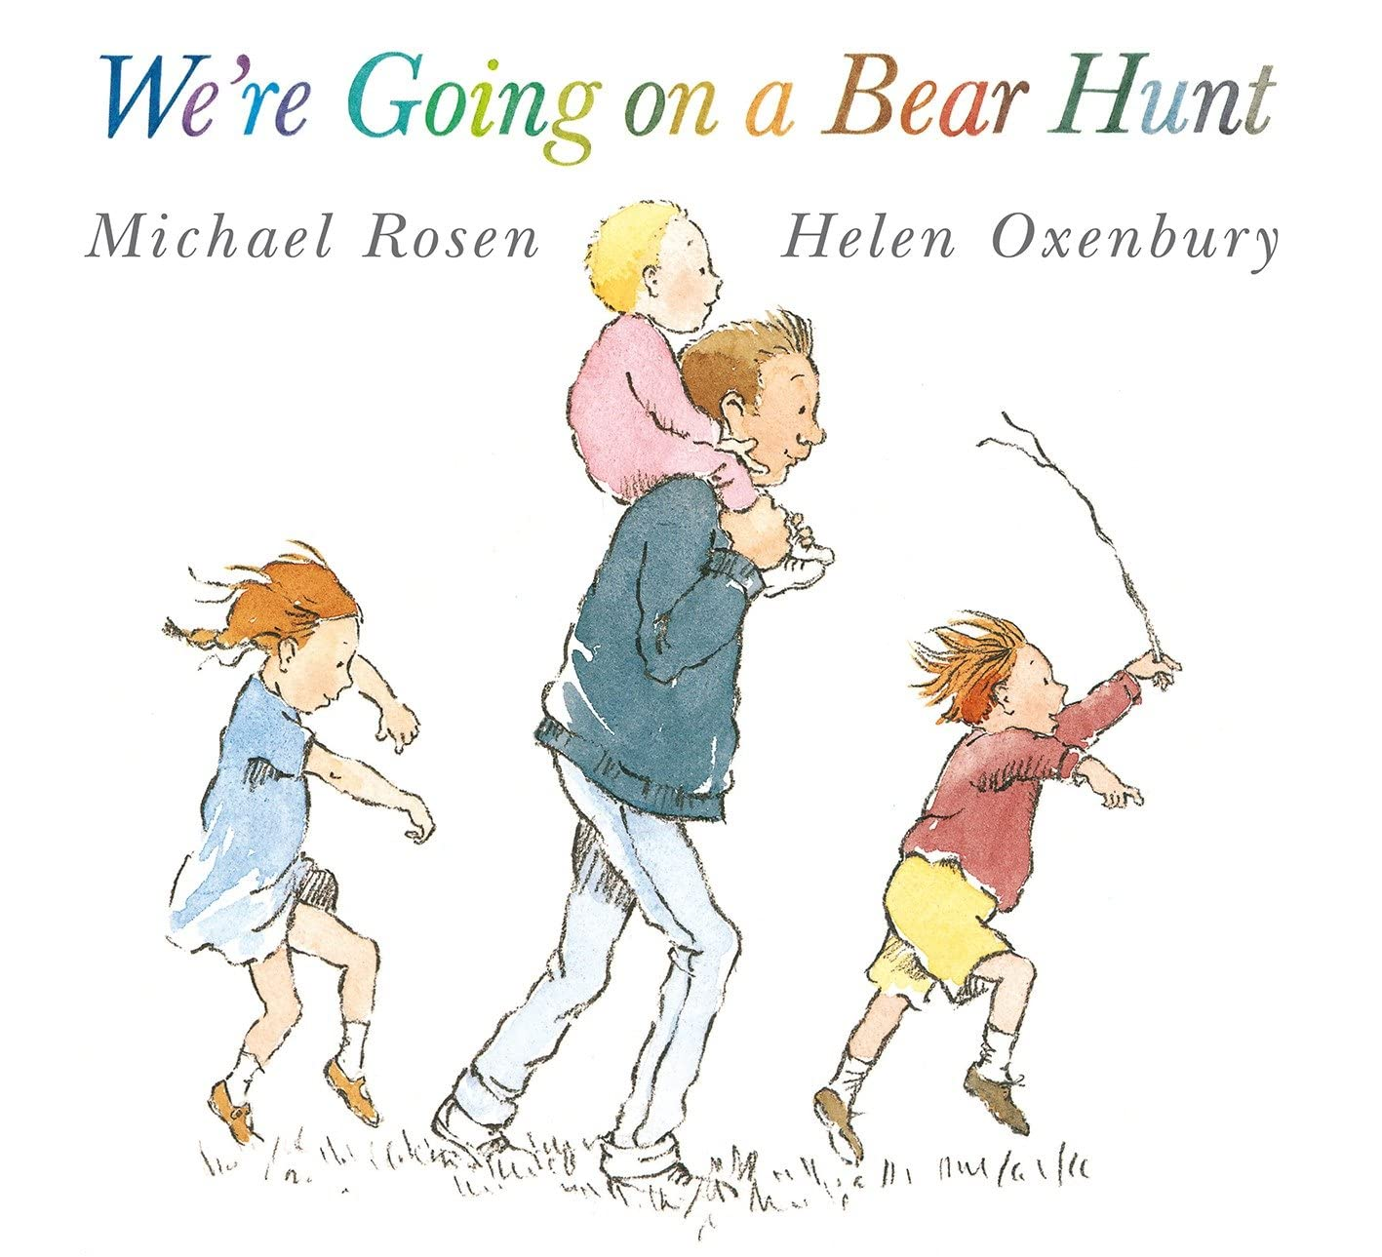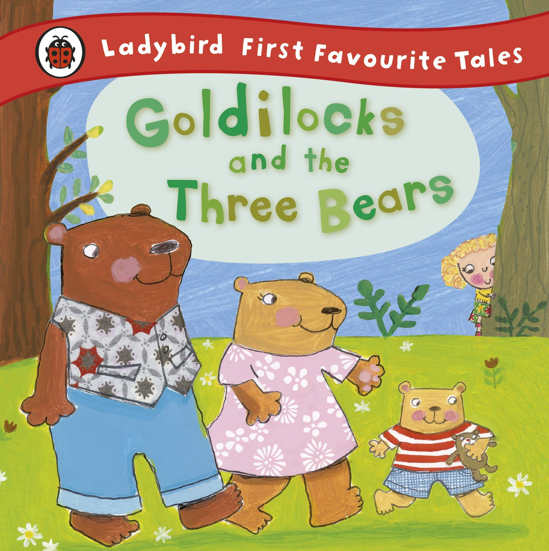 | 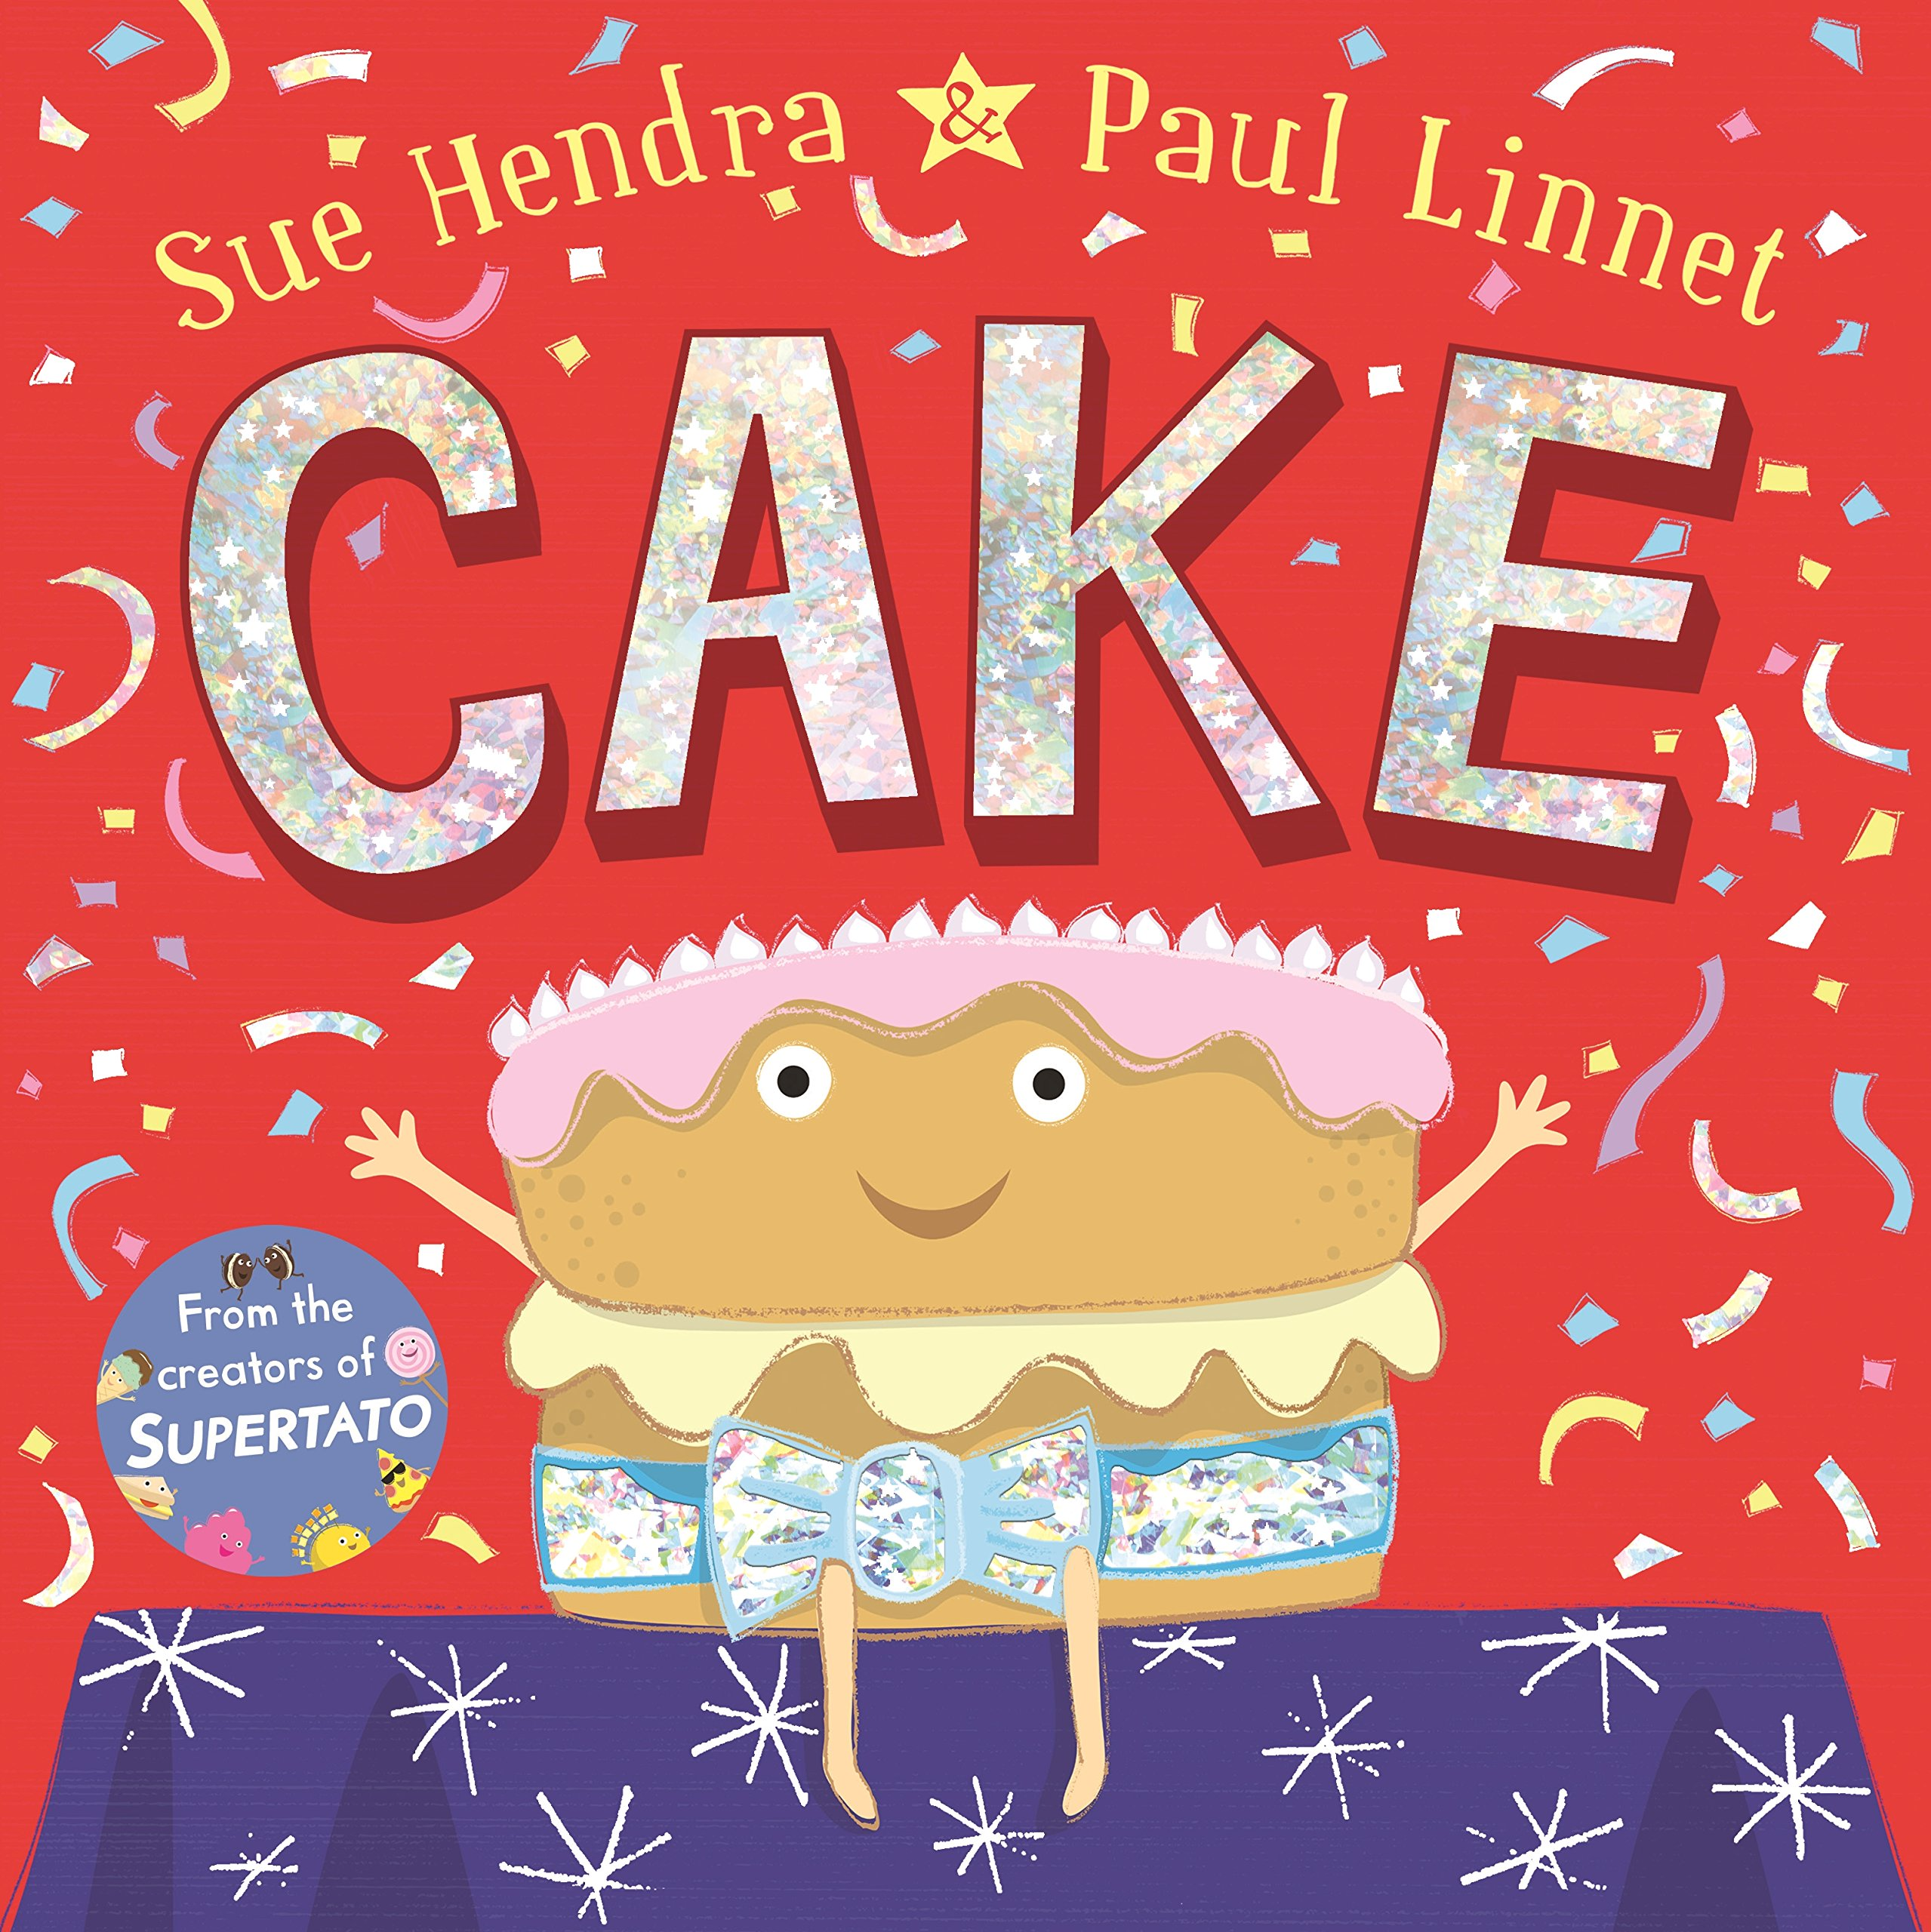  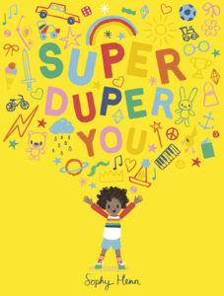  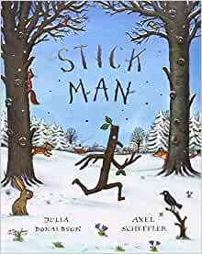 | 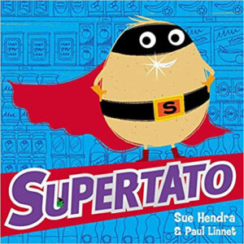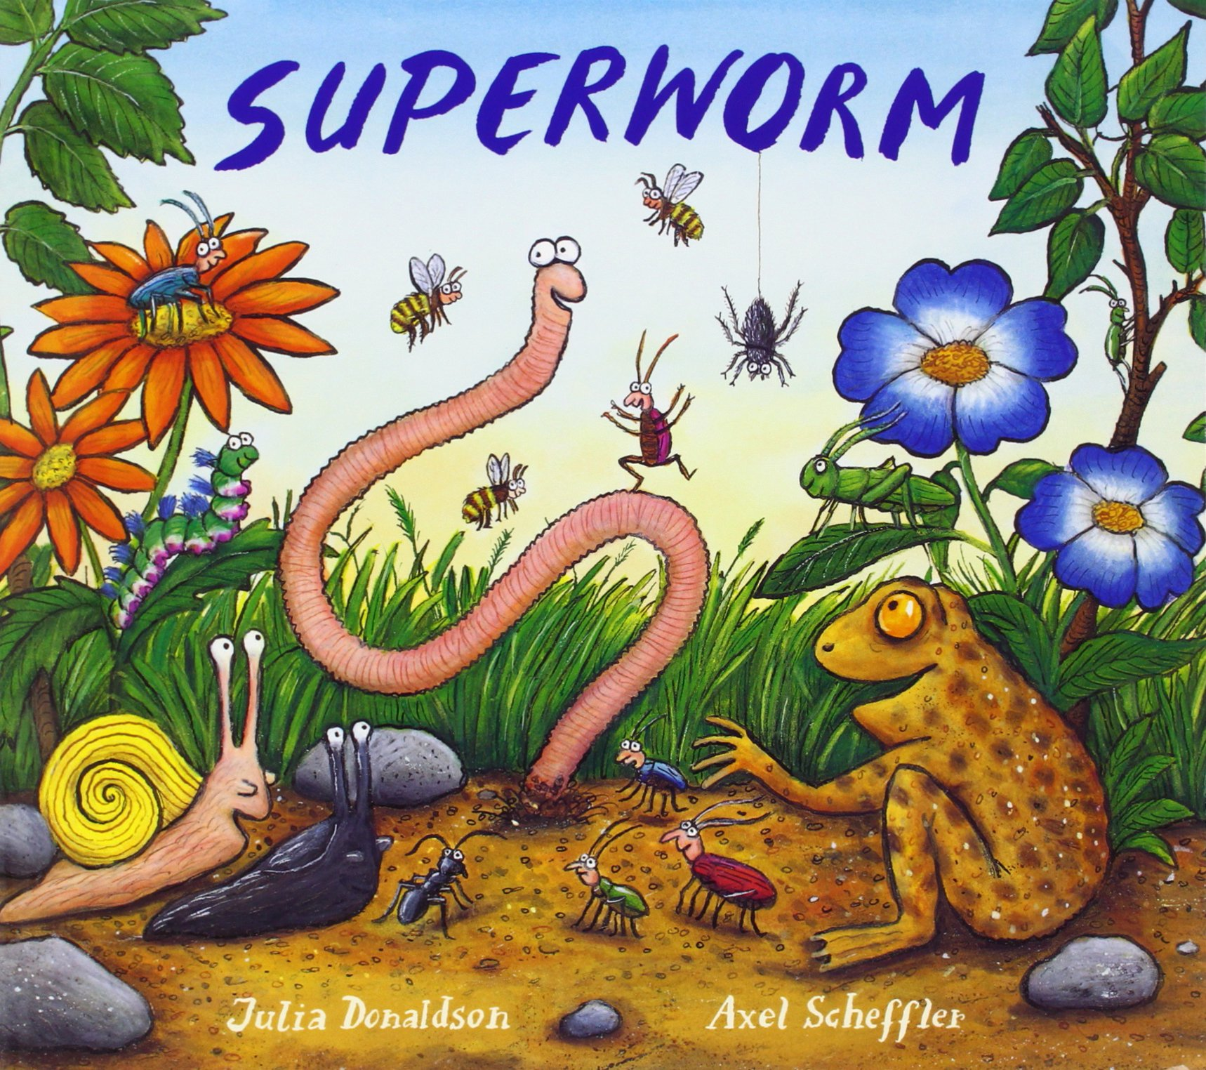 | 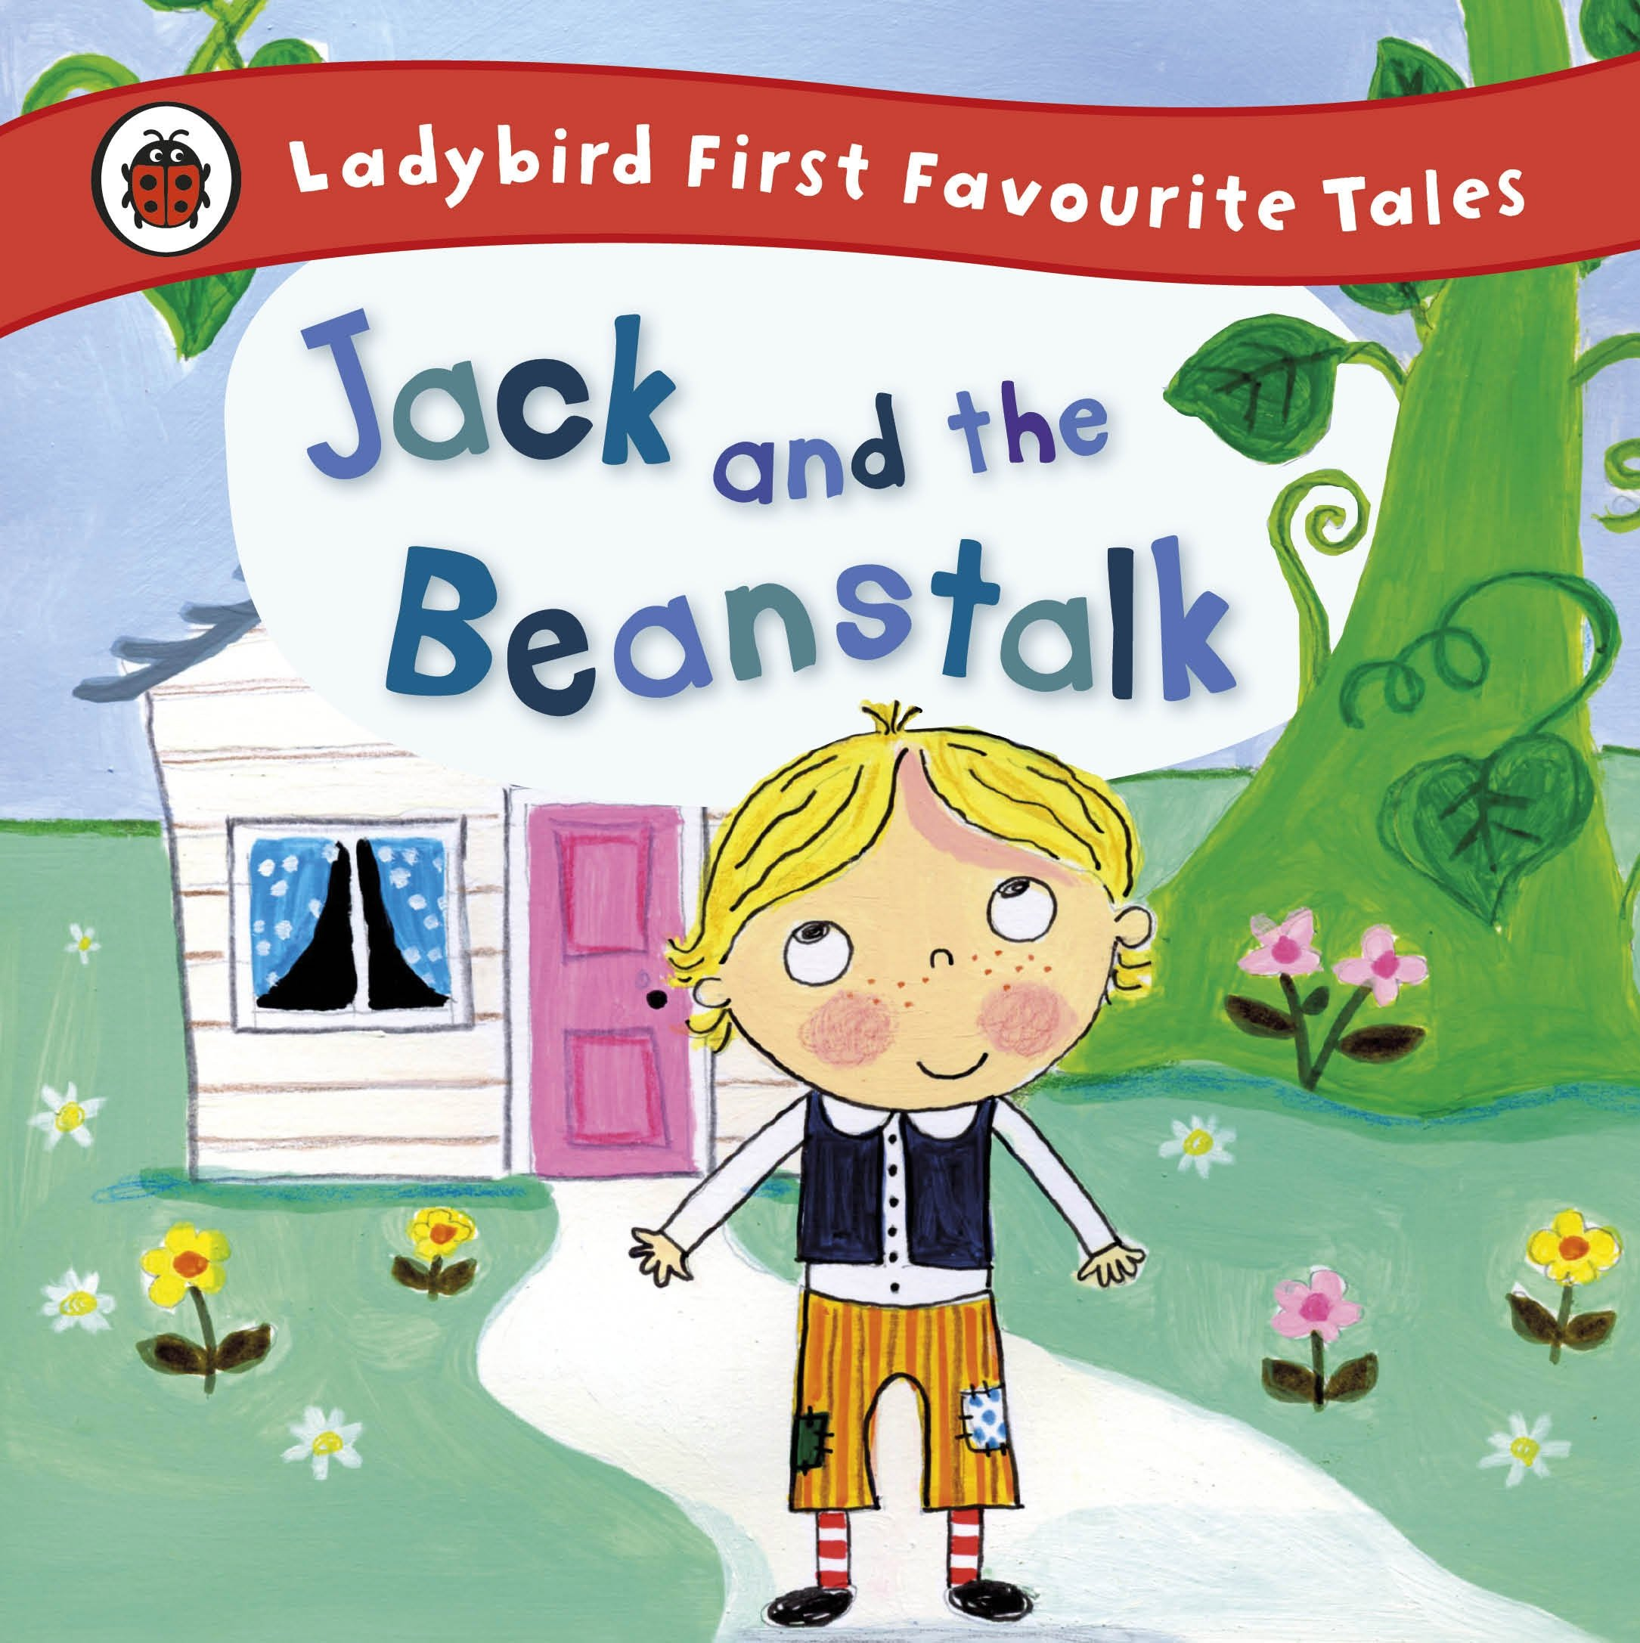 | 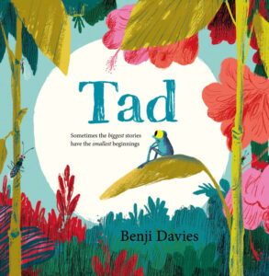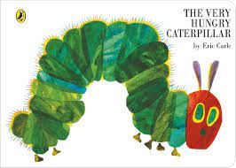

 | Autumn 1  Where do you belong? | Autumn 2  How do you celebrate? | Spring 1  Who is your superhero? | Spring 2  Have you got green fingers? | Summer 1  Who laid this egg? | Summer 2  Where would you like to go?
Communication and Language
The development of children’s spoken language underpins all seven areas of learning and development. Children’s back-and-for the interactions from an early age form the foundations for language and cognitive development. The number and quality of the conversations they have with adults and peers throughout the day in a language-rich environment is crucial. By commenting on what children are interested or doing, and echoing back what they say with new vocabulary added, practitioners will build children’s language effectively. Reading frequently to children and engaging them actively in stories, non-fiction, rhymes and poems, and then providing them with extensive opportunities to use and embed new words in a range of contexts will give children the opportunity to thrive. Through conversation, story-telling and role-play, where children share their ideas with support and modelling from their teacher, and sensitive questioning that invites them to elaborate, children become comfortable using a rich range of vocabulary and language structures.
Listening, Attention and Understanding  Speaking  ELGs | - Know and understand how to listen carefully and why listening is important.  - Know and talk about the school rules and how they help to keep us safe.  - Engage in story times.  - Join in with familiar stories and rhymes.  - Listen attentively and respond to what they hear with relevant questions, comments and actions when being read to and during whole class discussion and small group interactions. | - Ask questions to find out more and to check they understand what has been said to them.  - Developing social phrases and engage in story times.  - Make comments about what they have heard and ask questions to clarify their understanding.  - Hold conversations when engaged in back-and-forth exchanges with their teacher and peers.  - Use the new vocabulary taught in discussions and play. | - Articulate ideas and thoughts in well-formed sentences.  - Connect one idea or action to another using a range of connectives.  - Engage in non-fiction books.  - Listen to and talk about selected non-fiction to develop a deep familiarity with new knowledge and vocabulary regarding different places around the world.  - Express ideas and feelings about experiences using full sentences, and begin to use past, present and future tenses with increasing accuracy. | - Describe events in some detail.  - Use talk to help work out problems and organise thinking and activities.  - Use talk to explain how things work and why they might happen.  - Offer explanations for why things might happen, making use of recently introduced vocabulary from stories, non-fiction, rhymes and poems when appropriate.  - Use the new vocabulary taught in topic in discussions and play.  - Participate in small group, class and one-to-one discussions, offering their own ideas, using recently introduced vocabulary. | - Describe events in some detail and talk about what they observe in the natural world and growing observations.  - Use talk to help work out problems and organise thinking and activities.  - Explain how things work and why they might happen regarding the environment.  - Offer explanations for why things might happen, making use of recently introduced vocabulary from stories, non-fiction, rhymes and poems when appropriate. | - Listen to and talk about stories to build familiarity and understanding.  - Engage in fiction and non-fiction books and talk about what they have read and what has been read to them.  - Listen to and talk about selected non-fiction to develop a deep familiarity with new knowledge and vocabulary.  - Offer explanations for why things might happen, making use of recently introduced vocabulary from stories, non-fiction, rhymes and poems when appropriate.  - Express ideas and feelings about experiences using full sentences, and begin to use past, present and future tenses with increasing accuracy.
Personal Social and Emotional Development
Children’s personal, social and emotional development (PSED) is crucial for children to lead healthy and happy lives, and is fundamental to their cognitive development. Underpinning their personal development are the important attachments that shape their social world. Strong, warm and supportive relationships with adults enable children to learn how to understand their own feelings and those of others. Children should be supported to manage emotions, develop a positive sense of self, set themselves simple goals, have confidence in their own abilities, to persist and wait for what they want and direct attention as necessary. Through adult modelling and guidance, they will learn how to look after their bodies, including healthy eating, and manage personal needs independently. Through supported interaction with other children they learn how to make good friendships, co-operate and resolve conflicts peaceably. These attributes will provide a secure platform from which children can achieve at school and in later life.
Self-regulation  Managing Self  Building Relationships | - Know the school rules and be able to talk about how they keep them happy and safe.  - See themselves as a valuable individual.  - Build constructive and respectful relationships.  - To know what to do if they are feeling worried.  - Express feelings and consider the feelings of others and regulate behaviour accordingly.  - Form positive attachments to adults & friendships with peers.  - Work and play cooperatively and take turns with others.  - Give focused attention to what their peers and the teacher are saying. |  | - Set and work towards simple goals.  - Show resilience and perseverance in the face of a challenge.  - Identify and moderate own feelings socially and emotionally.  - Display confidence to try new activities. | - Know the importance of excerise and how to keep healthy.  - Know how to stay safe.  - Show understanding of their own feelings and those of others and begin to regulate their behaviour accordingly.  - Manage own basic hygiene and personal needs. | - Know how to be a good friend.  - Think about the perspectives of others.  - Show understanding of own feelings and those of others and begin to regulate own behaviour accordingly.  - Show sensitivity to their own and to others’ feelings. | - Know how we grow and change.  - Show sensitivity to their own and to others’ feelings.  - Display confidence to try new activities and show resilience and perseverance in the face of a challenge.  - Explain the reasons for rules and know right from wrong.

 | Autumn 1  Where do you belong? | Autumn 2  How do you celebrate? | Spring 1  Who is your superhero? | Spring 2  Have you got green fingers? | Summer 1  Who laid this egg? | Summer 2  Where would you like to go?
Physical Development
Physical activity is vital in children’s all-round development, enabling them to pursue happy, healthy and active lives. Gross and fine motor experiences develop incrementally throughout early childhood, starting with sensory explorations and the development of a child’s strength, co-ordination and positional awareness through tummy time, crawling and play movement with both objects and adults. By creating games and providing opportunities for play both indoors and outdoors, adults can support children to develop their core strength, stability, balance, spatial awareness, co-ordination and agility. Gross motor skills provide the foundation for developing healthy bodies and social and emotional well-being. Fine motor control and precision helps with hand-eye co-ordination which is later linked to early literacy. Repeated and varied opportunities to explore and play with small world activities, puzzles, arts and crafts and the practice of using small tools, with feedback and support from adults, allow children to develop proficiency, control and confidence.
Gross Motor Skills  P.E  Our outdoor provision is carefully selected to provide opportunities to develop gross motor skills, balance, core stability and stimulate the vestibular system. | Get set 4 PE  Introduction to PE unit 1  - I use movement skills with developing balance and co-ordination.  - I can make independent choices.  - I follow instructions involving several ideas or actions.  - I can negotiate space safely with consideration for myself and others.  - I can demonstrate balance.  - I play co-operatively and take turns with others | Get set 4 PE  Gymnastics unit 1  - I can negotiate space safely with consideration for myself and others.  - I can confidently and safely use a range of large and small apparatus.  - I can combine movements, selecting actions in response to the task and apparatus.  - I use movement skills with developing strength, balance and co-ordination showing increasing control and grace.  - I follow instructions involving several ideas or actions.  - I work co-operatively with others and take turns.  - I am confident to try new challenges. | Get set 4 PE  Dance Unit 1  - I can negotiate space safely with consideration for myself and others.  - I am confident to try new challenges and perform in front of others.  - I use movement skills with developing strength, balance and co-ordination showing increasing control and grace.  - I follow instructions involving several ideas or actions.  - I can combine movements, selecting actions in response to the task.  - I show respect towards others when providing feedback. | Get set 4 PE  Fundamentals Unit 1  - I can negotiate space safely with consideration for myself and others.  - I play games honestly with consideration of the rules.  - I am confident to try new challenges.  - I follow instructions involving several ideas or actions.  - I use movement skills with developing balance and co-ordination when playing games.  - I play co-operatively, take turns and encourage others. | Get set 4 PE  Ball Skills Unit 1  - I can negotiate space safely with consideration for myself and others.  - I use ball skills with developing competence and accuracy.  - I play co-operatively and take turns with others.  - I can make independent choices.  - I persevere when trying new challenges.  - I play ball games with consideration of the rules. | Get set 4 PE  Athletics  - I am able to throw towards a target.  - I am beginning to show balance and coordination when changing direction.  - I am developing overarm throwing.  - I can recognise changes in my body when I do exercise.  - I can run at different speeds.  - I can work with others and make safe choices.  - I try my best.  - I understand the difference between a jump, a leap and a hop and can choose which allows me to jump the furthest.
Fine Motor Skills  Our provision is carefully planned to provide opportunities to develop fine motor skills. | - Use a dominant hand to be able to mark make using different shapes.  - Use a tripod grip when using mark making tools.  - Begin to copy letters.  - Hold scissors and make snips.  - Hold a fork and spoon with increasing control.  - Begin to form most letters correctly. | - Use anti-clockwise movement and retrace vertical lines.  - Hold scissors correctly and cut along a straight line and zigzagged lines.  - Use a tripod grip when using mark making tools.  - Draw lines, circles and shapes to draw pictures.  - Write taught letters using correct formation and starting in the correct place.  - Begin to hold a knife correctly and use to cut. | - Use a tripod grip when using mark making tools.  - Hold scissors correctly and cut along a curved line.  - Write taught letters using correct formation. | - Hold scissors correctly and cut out large shapes.  - Write letters using the correct letter formation and control the size of letters. | - Hold scissors correctly and cut out small shapes.  - Write letters inline with the school handwriting policy.  - Paint using thinner paintbrushes. | - Hold scissors correctly and cut various materials.  - Write letters inline with the school handwriting policy.  - Create drawings with details.  - Independently use a knife fork and spoon to eat a range of meals.

 | Autumn 1  Where do you belong? | Autumn 2  How do you celebrate? | Spring 1  Who is your superhero? | Spring 2  Have you got green fingers? | Summer 1  Who laid this egg? | Summer 2  Where would you like to go?
Literacy
It is crucial for children to develop a life-long love of reading. Reading consists of two dimensions: language comprehension and word reading. Language comprehension (necessary for both reading and writing) starts from birth. It only develops when adults talk with children about the world around them and the books (stories and non-fiction) they read with them, and enjoy rhymes, poems and songs together. Skilled word reading, taught later, involves both the speedy working out of the pronunciation of unfamiliar printed words (decoding) and the speedy recognition of familiar printed words. Writing involves transcription (spelling and handwriting) and composition (articulating ideas and structuring them in speech, before writing).
Phonics  Little Wandle | Phase 2 sounds  S, a, t, p, i, n, m, d, g, o, c, k, ck, eur, h, b, f, l  Tricky words:  is, I , the | Phase 2 sounds  Ff, ll, ss, j, v, w, x, y, z, zz, qu, ch, sh, th, ng, nk  Words with s /s/ added at the end.  Words with s /z/ at the end.  Tricky words:  put, pull, full, as, and, has, his, her, go, no, to into, she, push, he, of, we, me, be | Phase 3 sounds  ai, ee, igh, oa, oo, oo, ar, or, ur, ow, oi, ear, air, er  Words with double letters: dd mm tt bb rr gg pp ff  Longer words  Tricky words:  was you they my by all are sure pure | Phase 3 sounds  Review GPCs from Spring 1  Review double letters and longer words  Words with 2 or more digraphs  words ending in –ing compound words  words with s in the middle /z/s  words ending –s  words with –es at end /z/  Review all tricky words taught so far and secure spelling. | Phase 4  Short vowels CVCC, CCVC  CCVCC, CCCVC, CCCCVCC  Longer words  Compound words  Root words ending:  -ing, -ed /t/, -ed /id/ /ed/ -est  Tricky words:  said, so, have, like, some, come, love, do, were, here, little, says, there, when, what, one, out, today | Phase 4  Long vowels CVCC, CCVC  CCVC, CCCVC, CCV, CCVCC  Phase 4 words ending:  -s /s/, -s /z/, -es  Longer words  Root words ending:  -ing, -ed /t/, -ed /id/ /ed/ , -ed /d/, -er, -est
Comprehension | - Join in with rhymes  - Show an interest in stories  - Understand the key concepts about print:  - Print has meaning.  - Print can have different purposes.  - We read English text from left to right and from top to bottom.  - The names of the different parts of a book. | - Join in with repeated refrains.  - To identify key vocabulary and discuss the meaning.  - Identify: front cover, back cover pages and spine.  - Act out key parts of the story and transfer this to imaginative play using expression and intonation.  - Use the vocabulary “author” and “illustrator”. | - To identify key vocabulary and discuss the meaning.  - Retell key parts of a story using a story map prompt.  - Begin making predictions about what will happen next.  - Identify who the author and illustrator of the story are. | - Make predictions using prior knowledge from stories.  - Begin to answer a range of questions about what has been read.  - Confidently identify the author, illustrator and begin to focus on the blurb and discuss the genre.  - Is the book fiction or non-fiction? Why? | - Listen to stories, accurately anticipating key events and respond to what they hear with relevant comments, questions and reactions.  - Use vocabulary that is influenced by their experiences of books within play.  - Act out the stories showing expression in Pie Corbett style. | - Retell stories in Pie Corbett style.  - Children to orally rehearse own stories using knowledge of stories read to them.  - Sort books into categories.  - Independently retrieve information from what is read to them.  - Answer questions using question stem.
Writing | - Correctly form graphemes and say the phonemes to match for sounds taught in phonics.  - Write initial sounds matched to phonic knowledge.  - Write own name.  - Write some words which have personal meaning e.g. Mum, Dad, sibling names. | - Segment and write CVC words.  - Write some short captions labels and sentences with adult support. | - Write recognisable letters most of which are correctly formed.  - Segment and spell words when writing independently matched to phonic knowledge.  - Begin to write sentences and build an awareness of capital letters, full stops and finger spaces. | - Write words that are phonetically plausible within sentences.  - To continue to build an awareness of capital letters full stops and finger spaces and use when writing sentences. | - Write sentences with increasing accuracy using phonics to identify sounds for writing.  - Spell tricky words with increasing accuracy.  - Begin to write for a given audience.  - Consistently use capital letters, full stops, finger spaces and writing on the line.  - Read back own writing. | - Write sentences that can be read by others.  - Introduce narratives in their own writing and story maps.  - Write tricky words accurately matched with phonic knowledge.

 | Autumn 1  Where do you belong? | Autumn 2  How do you celebrate? | Spring 1  Who is your superhero? | Spring 2  Have you got green fingers? | Summer 1  Who laid this egg? | Summer 2  Where would you like to go?
Maths
Developing a strong grounding in number is essential so that all children develop the necessary building blocks to excel mathematically. Children should be able to count confidently, develop a deep understanding of the numbers to 10,
the relationships between them and the patterns within those numbers. By providing frequent and varied opportunities to build and apply this understanding – such as using manipulatives, including small pebbles and tens frames for organising counting – children will develop a secure base of knowledge and vocabulary from which mastery of mathematics is built. In addition, it is important that the curriculum includes rich opportunities for children to develop their spatial reasoning skills across all areas of mathematics including shape, space and measures. It is important that children develop positive attitudes and interests in mathematics, look for patterns and relationships, spot connections, ‘have a go’, talk to adults and peers about what they notice and not be afraid to make mistakes.
Mental/Oral  (Number Sense)  Maths  White Rose | Number rhymes.  Getting to know you  - Introducing areas of provision.  - Turn taking number games.  Just like me  - Match, sort, compare sets.  - Compare size, mass, capacity.  - Simple patterns. | Subitising quantities to 3  Subitising quantities to 5  It’s me 1, 2, 3!  - Representing, comparing, composition of 1,2,3  - Circles and triangles  - Spatial awareness  - 1p, 2p  Light and Dark  - Representing, subitising 4 and 5  - Squares, rectangles, pentagons  - One more and one less  - Night and day  - 5p | Enumeration between 6 and 10  Alive in 5  - Introducing zero  - Comparing numbers to 5  - Composition of 4 & 5  - Compare mass  - Compare capacity  Growing 6,7,8  - Representing, subitising, composition of 6,7,8  - Making pairs  - Combining 2 groups  - Length and height  - Time | Partitioning 2,3,4,5, and 10 and Number Bonds  Building 9,10  - Representing, subitising, composition of 9 and 10  - Comparing numbers to 10  - Bonds to 10  - 3d shape  - Pattern  - 10p & coins that make 10p | Composition of 6-9 and comparison of numbers to 10  To 20 and beyond  - Building numbers beyond 10  - Counting patterns beyond 10  - Spatial reasoning – match, rotate, manipulate  First, then, now  - Adding more  - Taking away  - Spatial reasoning – compose and decompose | Patterns in numbers to 10  Find my pattern  - Doubling  - Sharing and grouping  - Spatial reasoning – visualise and build  On the move  - Deepening understanding  - Patterns and relationships  - Spatial reasoning – mapping
Understanding the World
Understanding the world involves guiding children to make sense of their physical world and their community. The frequency and range of children’s personal experiences increases their knowledge and sense of the world around them – from visiting parks, libraries and museums to meeting important members of society such as police officers, nurses and fire-fighters. In addition, listening to a broad selection of stories, non-fiction, rhymes and poems will foster their understanding of our culturally, socially, technologically and ecologically diverse world. As well as building important knowledge, this extends their familiarity with words that support understanding across domains. Enriching and widening children’s vocabulary will support later reading comprehension.
Past and Present  History | - Talk about members of their immediate family and community.  - Talk about themselves in the past when they were younger and make sense of their family history.  - Talk about family and who is older and who is younger.  Key concepts: chronology | - Know some historical facts and stories from different religions and celebrations.  - Compare and contrast characters from stories including figures from the past.  - Understand the past through setting, characters and events encountered in books read in class and story telling. (Guy Fawkes) | - Comment on images of familiar situations in the past.  - Compare characters from stories including figures from the past.  - Be able to talk about historical figures from the past – real life superheroes! | - Comment on images of familiar situations in the past (parks).  - Know some similarities and differences between things in the past and now, drawing on their experiences and what has been read in class.  - Understand the past through setting, characters and events encountered in books read in class and story telling. | - Personal timeline – how have we changed since we were born.  - Recognise that some animals no longer exist (are extinct).  - Similarities / differences with animals of today. | - Talk about own personal life and look at past year (link to transition).  - Create a time line of the year.
People, Cultures, Communities  Geography  RE | - Talk about the lives of people around them and their roles in society.  Locational Knowledge  - Know where I live.  - Know about the features of my own immediate environment.  Geographical Skills and Fieldwork  - Know that aerial maps are taken from above like a bird’s eye view and can comment on simple features. | - Recognise that people have different beliefs and celebrate special times in different ways.  - Know about different celebrations that occur in Autumn (Diwali, Hanukkah, Remembrance Day, Christmas and Black History Month).  - Explore that people around the world have different religions. | - To talk about Chinese New Year.  - Recognise some similarities and differences between life in this country and life in other countries.  - To know that there are many countries around the world.  Locational Knowledge  - To know where we live and celebrate our local environment. | - To know that Christians celebrate Easter.  - Recognise similarities and differences between different religions and cultures.  Place Knowledge  - Know environments vary from one another.  - Know about similarities and differences between places drawing on my experiences and what has been read in class. | - To know that Muslims celebrate Eid.  - Continue to show respect and tolerance for those with different faiths and beliefs or those without beliefs.  - Know how to use and draw information from a simple map. | - Recognise that some countries are hotter than the country we live in.  - Recognise some similarities and differences between life in this country and life in other countries.  Geographical Skills and Fieldwork  - Know how to make simple maps of a familiar place or imaginary world.  - Know that simple symbols are used to identify features on a map.
The Natural World  Science | - Explore the natural world around them (school garden, Botanical gardens).  - Make observations and draw pictures of seasonal change.  - Describe what they see on seasonal walks.  - Name parts of their body.  - Know the life cycle of a human – baby, toddler, child, teenager, adult, elderly. | - Describe what they see and hear on seasonal walks.  - Autumnal change. How does this affect the weather, clothes that we wear? | - Describe what they see and hear and feel on seasonal walks.  - Changing states of matter – water becoming ice, snow melting. | - Explore the natural world around them.  - Understand the effect of the changing seasons on the natural world around them – Spring / planting.  - Know what a plant needs to grow.  - Explain how plants grow through observation of plants growing in class and in the garden.  - Compare the natural world in different places in our locality, with a focus on the plants found there. | - Explore the natural world around them making observations and drawing animals and plants- focusing on the life-cycle of a butterfly.  - Understand some important process and changes in the natural world around them – life cycles. | - Observe seasonal change. What happens during the summer? How does this affect the weather, what we wear, how to keep safe?  - Changing states of matter matter: Why do things melt when it is hot?  - Forces and motion: floating and sinking.
Expressive Arts and Design
The development of children’s artistic and cultural awareness supports their imagination and creativity. It is important that children have regular opportunities to engage with the arts, enabling them to explore and play with a wide range of media and materials. The quality and variety of what children see, hear and participate in is crucial for developing their understanding, self-expression, vocabulary and ability to communicate through the arts. The frequency, repetition and depth of their experiences are fundamental to their progress in interpreting and appreciating what they hear, respond to and observe.
Creating with Materials  Art and DT | - Name colours.  - Experiment with colour.  - Know colours can be mixed to make a new colour.  - Create representations of people and objects.  - Experiment with different mark making tools such as art pencils, pastels, chalk. | - Create arts and crafts from different cultures e.g. Rangoli patterns, Divas, Christmas decorations, Hanukkah cards.  - Explore different techniques for joining materials (glue stick).  - Manipulate clay.  - Thread beads. | - Explore different techniques for joining materials (glue, pva, masking tape, tape).  - Use props when role playing characters in narratives and stories. | - Share creations and talk about the process.  - Explore different techniques for joining materials (glue stick, PVA, masking tape, tape, split pins).  - Observational drawing. | - Know which prime colours you mix together to make secondary colours.  - Use a range of materials to make a collage.  - Know some similarities and differences between materials. | - Learn about and compare artists.  - Explore, use and refine a variety or artistic effects to express their ideas and feelings.  - Share creations, talk about process and evaluate their work.
Being imaginative and expressive  Role play / dance / music | - Develop storylines in their pretend play.  - Play with others who are engaged in the same theme.  - Listen attentively, move to and talk about music.  - Copycat rhythm games.  - Singing rhymes. | - Invent narratives in role play.  - Play with others during role play who are engaged in the same theme.  - Sing and perform songs and rhymes.  - Move in time to the music.  - Listen attentively, talk about music: rhythm, pitch. | - Use a storyline or narrative in their play.  - Recount narratives with peers.  - Learn and perform dance routines.  - Move in time with the music.  - Listen attentively, talk about music: rhythm, pitch, pulse | - Perform stories to their peers.  - Recount narratives with peers.  - Sing and perform songs and rhymes.  - Listen attentively, talk about music: rhythm, pitch, pulse, tempo. | - Perform stories to their peers.  - Recount narratives with peers.  - Sing and perform songs and rhymes.  - Explore percussion instruments.  - Play instruments in the song. | - Invent, adapt and recount narratives and stories.  - Sing a range of well known nursery rhymes and songs.  - Sing and perform songs and rhymes.  - Explore tuned percussion instruments.  - Play instruments in the song.

