Writing Curriculum Year 1
 | Autumn 1 | Autumn 2 | Spring 1 | Spring 2 | Summer 1 | Summer 2
 | Where do you belong? | Why should we Remember? | What makes Sheffield green? | Is steel still made in Sheffield? | Why do lions roar? | Would you choose wheels or wings?
 | Geography, History, PHSE | RE, Science, History | Geography, DT, RE | Art, History | PHSE, Geography | Science, Art, Geography.
Spotlight Author | Floella Benjamin | Michael Rosen | Oliver Jeffers | Joanna Ho | Nadia Shireen | Patricia Heggarty
Key Texts | The Chimpanzees of Happy Town  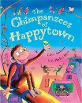  Little People, Big Dreams – Rosa Parks. 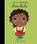 | Visual text. CBeebies Poppy video for Remembrance.  Immersion – Christmas performance.  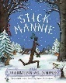  The Elves and Shoemaker  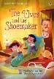 | 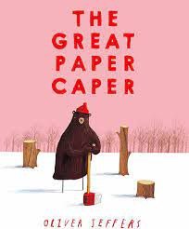  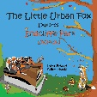 | 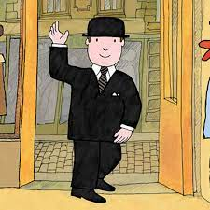  Mr Benn  Visual text – youtube video of tour of Kelham Island/ Sheffield City on the Move. | Oak Academy unit – All about Tigers. | 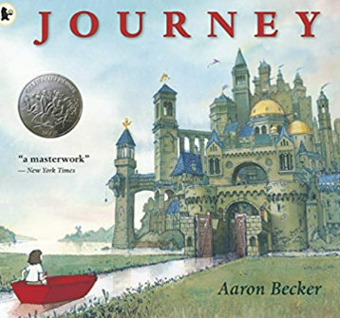  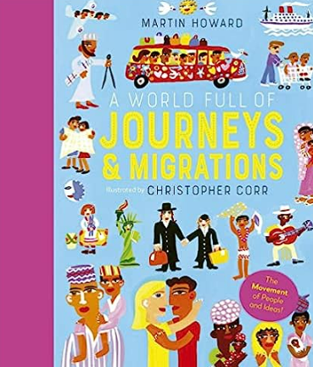  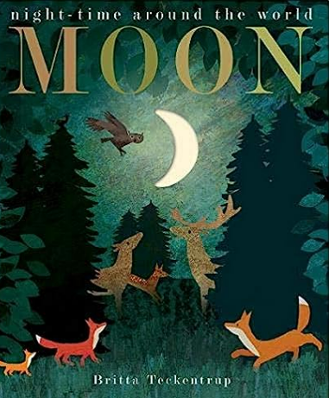
Focus | Narrative/ rhyming texts.  Auto-biography/ Biography of Floella Benjamin. | Remembrance - Poetry  Explanation text – Why do we celebrate Bonfire Night?  Narrative – own version of The Elves and the Shoemaker. | Persuasive writing – saving our trees  Narrative – Urban fox adventure in our FS | Narrative in imaginary world.  Information text – All about Sheffield | Innovate the story – change animal and packet!  Explanation text- how animals adapt to their environment. | Narrative  Autobiography for new teachers.
 | Introduce story with rhyming sentences.  Revise capital letters and full stops.  Introduce questions and question words.  Generate rhyming sentences to make a class book.  Look at non- fiction books and recognise criteria.  Practise oral composition of sentences.  Use ‘and’ in a sentence. | Understand what a poem is – discuss the effects of poetry.  Develop understanding of rhyme.  Understand verbs.  Understand stories have a beginning, middle and end.  Capital letters for common nouns.  Focus on orally retelling the whole story.  By Christmas  - Independently use finger spaces.  - Read aloud their writing loudly enough to be heard by peers and teachers. | Sequence at least three single clause sentences.  Children reread what they have written for errors.  Consistently use capital letters and full stops. | Children becoming more confident with composing sentences orally and ensuring they read it to check it makes sense.  Complex narrative between real and imaginary world.  Develop capital letters for proper nouns and introduce the pronoun ‘I.’  Use ‘but’ and ‘or’ to link sentences.  Develop understanding of non-fiction texts.  More complex sentence starters for simple sentences.  Exposure to more complex vocabulary.  Children more independent with their use of ‘and’ to join two clauses. | Story with sequencing sentences is far more complex.  More independent use of ‘and’.  Introduction of adjectives.  Introduction of alliteration. Introduction of direct speech using speech bubbles – guided.  Introduction to non-fiction writing with exposure to different nonfiction features – headings, sub-heading, images, labels and captions.  Independent use of ‘and’.  Children should be able to use full stops and capital letters to start sentences and for proper nouns with increasing accuracy – eg. not just putting capital letters in the middle of words and not just using full stops at the end of a line. | Develop positive attitudes towards stamina for writing by writing about personal experience and those of others.  Sequence sentences to form short narratives. Understand how to use a question mark independently.  Different type of narrative plot with a twist at the end. Understand how to use an exclamation mark independently.  More confidence, sequencing sentences with precision. Independent use of capital letters for proper nouns.

Termly end point | By the end of the Autumn Term, the children in Year 1 will have experienced and have some understanding of a range of genres. They will have more confident in vocalising what they want to write which will help them to form sentences. They will be able to use capital letters correctly. | By the end of the Spring Term, the children will have built on their understanding of different text types and will become more independent writers, with more stamina and positivity. They will show an improvement in their ability to orally rehearse sentences | By the end of the Summer Term, the children will have been exposed to a range of genres and will be more competent writers who will be able to write narratives with more complex plot lines and ranging non-fiction texts.

Grammar and punctuation
 | Begin to punctuate sentences using a capital letter and a full stop, question mark or exclamation mark.  Leave spaces between words.  Joining words and joining clauses using and understanding how words can combine to make sentences. | Leave spaces between words.  Combining words to make sentences.  Beginning to punctuate sentences using a capital letter and a full stop, question mark or exclamation mark.  Using a capital letter for names of people. | Begin to punctuate sentences using a capital letter and a full stop, question mark or exclamation mark  Using a capital letter for names of people, places, the days of the week and the personal pronoun ‘I’.  Sequence sentences. | Understand how words can combine to make sentences.  Begin to punctuate sentences using a capital letter and a full stop, question mark or exclamation mark.  Using a capital letter for names of people, places, the days of the week and the personal pronoun ‘I’. Understanding separation of words with spaces.  Sequence sentences. | Leave spaces between words.  Joining words and joining clauses using ‘and’.  Understanding how words can combine to make sentences. Begin to punctuate  sentences using a capital letter and a full stop, question mark or exclamation mark.  Sequence sentences. | Begin to punctuate sentences using a capital letter and a full stop, question mark or exclamation mark.  Using a capital letter for names of people, places, days of the week and the personal pronoun ‘I’.
 | Leave spaces between words.  Joining words to make sentences and joining words and clauses/senten ces using and. Begin to punctuate sentences using a capital letter and a full stop, question mark or exclamation mark. | Leave spaces between words. | Leave spaces between words.  Learning how words can combine to make sentences.  Beginning to punctuate sentences using a capital letter and a full stop, question mark or exclamation mark.  Using a capital letter for names of people, places, the days of the week and the personal pronoun ‘I’. | Leave spaces between words.  Joining words to make sentences  and joining words and clauses/sentences using and. Begin to punctuate sentences using a capital letter and a full stop, question mark or exclamation mark. | Leave spaces between words. Begin to punctuate sentences using a capital letter and a full stop or question mark. Sequence sentences. | Begin to punctuate simple sentences using a capital letter and a full stop or exclamation mark. Sequence sentences. Using a capital letter for names of people, places, days of the week and the personal pronoun ‘I’.

