Writing Curriculum Year 2
 | Autumn 1 | Autumn 2 | Spring 1 | Spring 2 | Summer 1 | Summer 2
 | Where do you belong? | Why should we Remember? | What makes Sheffield green? | Is steel still made in Sheffield? | Why do lions roar? | Would you choose wheels or wings?
Curriculum Links | Geography, History, PHSE | RE, Science, History | Geography, DT, RE | Art, History | PHSE, Geography | Science, Art, Geography.
Spotlight Author | Floella Benjamin | Michael Rosen | Oliver Jeffers | Joanna Ho | Nadia Shireen | Patricia Heggarty
Key Texts | The Chimpanzees of Happy Town  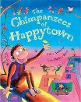  Little People, Big Dreams – Rosa Parks. 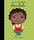 | Visual text. CBeebies Poppy video for Remembrance.  Immersion – Christmas performance.  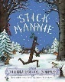  The Elves and Shoemaker  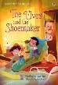 | 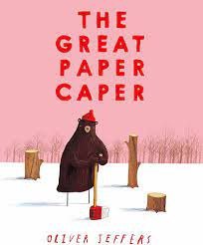  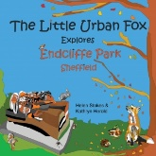 | 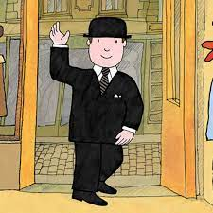  Mr Benn  Visual text – youtube video of tour of Kelham Island/ Sheffield City on the Move. | Oak academy unit – All about Tigers. | 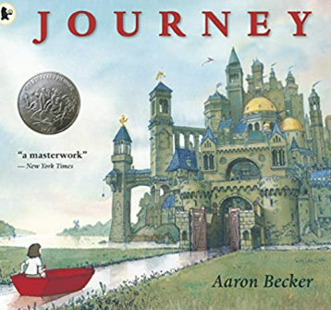  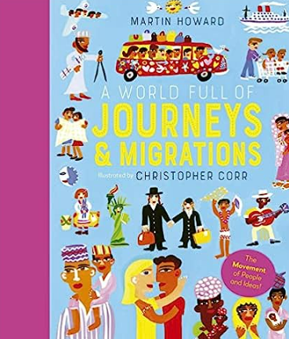  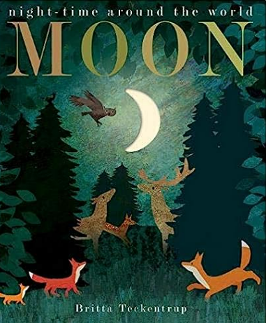
Independent Purposeful Writing Outcomes | To write a narrative using rhyming sentences/ phrases.  To write an autobiography. | To write a poem to commemorate Remembrance Day.  To write an explanation text about why we celebrate Bonfire Night.  To familiarise themselves with Stick Man in preparation for the Christmas performance.  To write own version of The Elves and the Shoemaker.  Or instructional writing – how to make shoes? | Non- chronological report – Trees/ woodland locally?  Narrative – Urban Fox adventure in school garden. | Narrative in imaginary world.  Information text | Innovate the story – change animal and packet!  Non-chronological report about an animal. | Narrative – a journey.  Letter to new teachers.
Strategic End Points | Story writing – plot focus.  Capital letters and full stops in simple clause sentences. Introduction to writing non-fiction – writing about self. To write in the present tense. Use question marks and exclamations and capital letters for proper nouns. Possessive apostrophe. | Poetic writing. Language for description – expanded noun phrases and consolidation of basic punctuation.  Know and use the features of non-fiction writing including using relevant vocabulary. | Write a story in a familiar setting.  Use CL for people’s names.  Expanded noun phrases including commas in a list. Conjunctions for coordination. Exclamation marks and question marks. | Write Mr Benn story using consistent tense.  To include lots of action – with progressive forms of verbs.  Write a non-chronological report about Sheffield.  To use a range of sentence types correctly punctuated. Expanded noun phrases to specify. | Write a narrative about the experience of others (or selves). Consistent use of past tense.  Subordination ‘when’ included. Writing for different purpose.  Consistent use of tense in non-fiction.  Range of subordination used to include when, if or because. | Cumulative journey story.  Introduction to subordination including when, if, that or because.

Termly end point | By the end of the Autumn Term, the children will have an awareness of different types of story and different story structures as well as instructional writing. Children will be able to correctly punctuate simple clause sentences. They will begin to build descriptions, using expanded noun phrases. They will use -ed past tense verbs in some of their writing independently. They will begin to develop an awareness of the features of some non-fiction texts. | By the end of the Spring Term, the children will have an awareness of non-fiction texts including non-chronological reports. They will be able to use differing sentence types, including questions and exclamations, and punctuate these correctly. They will also have built their descriptive vocabulary and be able to use expanded noun phrases more confidently. | By the end of the Summer Term, the children will be able to write for a range of purposes. They will be secure in the range of punctuation taught throughout the year. They will confidently use differing sentence types, including statements, commands, questions and exclamations, and will show use of coordination and subordination. By now, they will be able to re- read their work to check for errors.

Grammar and punctuation | Full stops, capital letters, exclamation marks, question marks Statement, question, exclamation, command Noun phrases to describe and specify.  Present and past tenses.  Expand noun phrases for description. | Full stops, capital letters, exclamation marks ,commas for lists and the possessive apostrophe (singular). Noun phrases to describe and specify.  The present and past tenses.  Full stops, capital letters, exclamation marks and question marks. | Question marks.  Exclamation marks  Noun phrases to describe.  Full stops, capital letters, commas for lists and apostrophes for contracted forms and the possessive (singular)  Expanded noun phrases to describe and specify  Present tense | Full stops, capital letters, exclamation marks, question marks Statement, question, exclamation, command Noun phrases to describe and specify . Make the correct choice and consistent use of present tense and past tense throughout writing. Use the progressive form of verbs in the present and past tense to mark actions in progress (e.g., she is drumming, he was shouting). | The present and past tenses correctly and consistently including the progressive form.  Subordination (using ‘when’, ‘if’, ‘that’, or ‘because’) and co-ordination (using ‘or’, ‘and’, or ‘but’).  Use the past tense consistently. Subordination using when. | Use the present and past tense correctly. Use subordination (using when, if, that or because.  Full stops, capital letters, exclamation marks, question marks , commas for lists and apostrophes for contracted forms  and the possessive (singular.)  Using expanded noun phrases to describe and specify.

